YAN WANG PRESTON: WITH LOVE
1 June – 1 July 2022
Press preview: Tuesday 31 May, 5 pm. Private View: 6:30pm Register interest here
Messums London, 28 Cork Street, London, W1S 3NG
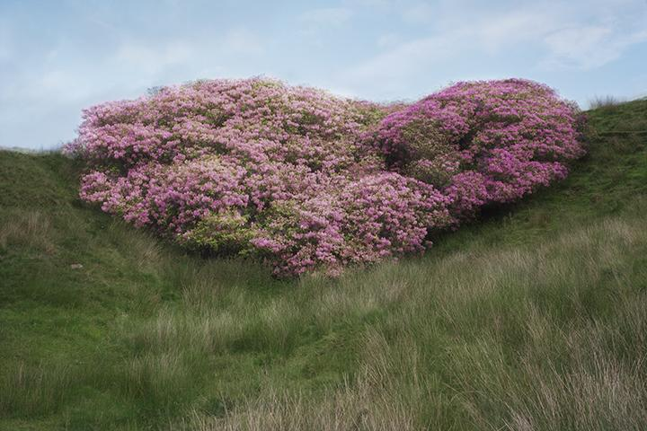
Figure 1: With Love. From an Invader. (lead image). 2020-2021. ©Yan Wang Preston
MESSUMS LONDON presents the first solo exhibition in London by the British-Chinese photographer Yan Wang Preston with two critically acclaimed bodies of work Mother River, Forest, and new releases from recent series With Love. From an Invader. and Autumn, Winter, Spring and Summer.
Curated byJohnny Messum and Zelda Cheatle, the exhibition begins with the epic journey that was Mother River. A breakthrough project in Wang Preston’s practice that excavates her relationship with the landscape and its undercurrents from representation, identity, migration and most recently, the body. Shown in London for the first time, Mother River (2010-2014) is a conceptual journey that saw Wang Preston photographing the entire 6,211 km of the Yangtze, China’s ‘Mother River’ at precise 100km intervals on a large format plate camera.

From the remote high Tibetan Plateau, through the Three Gorges and on to the river’s mouth at Shanghai, the photographs capture the dramatic shifts in landscape and offer a multi-layered perspective on China’s present day development. The result is the most systematic record of China’s landscape along the Yangtze completed by one person since 1842, the year when photography began in the country. Mother River is a modern-day adventure, a rigorous artistic concept and an epic yet consuming physical process that marks the beginning of Wang Preston’s performative photographic practice.
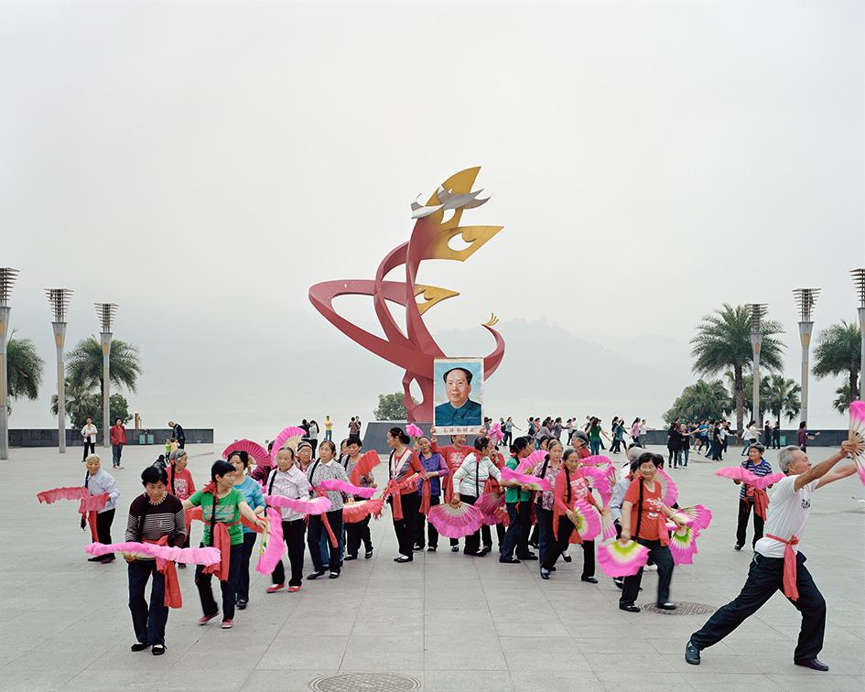
Figure 2: Y40_3,900km from the river source. From Mother River series (2010-2014). ©Yan Wang Preston

Responding to the nationwide practice of making greener cities, Wang Preston spent eight years (2010-2017) investigating the politics of recreating forests and the ‘natural’ environment in new Chinese cities. Following the trails of transplanted old trees in new towns, the artist embarked on a journey of erasure and contradictions. Her observations developed into Forest, an award winning project that highlights the attempts, failures and hopes of recreating nature for urban consumption at a scale that is unsettling.

In more recent works, Wang Preston’s interventions are guided by a need to connect with her chosen homeland, here in the UK. Still the observer, Preston marks her presence while exploring what it is to be a foreign body in a foreign land. For the durational piece, With Love. From an Invader. Wang Preston walked to the same love heart shaped rhododendron bush in Lancashire from the 17th March 2020 to the 16th March 2021 at the frequency of every other day. A photograph of the rhododendron was taken each time, in identical manners, always at half an hour before sunset. Sights and sounds collected from these walks, in particular, animal movements, captured by infrared cameras placed in the area, complete the work as a multi-channel video and audio installation. The Messums exhibition introduces the work as a series of four photographic prints documenting the changing landscape of the rhododendron bush.
Rhododendron was chosen for this project, for many reasons. Introduced to the UK by colonial botanists in the late 19th centenary as an ornamental plant, it is now regarded as a non-native and invasive species. Many of the rhododendron species currently grown in Britain are originally from China, Wang Preston's motherland. Hidden in the heartland of the South Pennines, in an ‘ecological wasteland’, the rhododendron landscape is simultaneously post-industrial and post-colonial. This particular bush happens to have the shape of a love heart. An alien species sending out love, it is a significant symbol to anchor Wang Preston’s research.
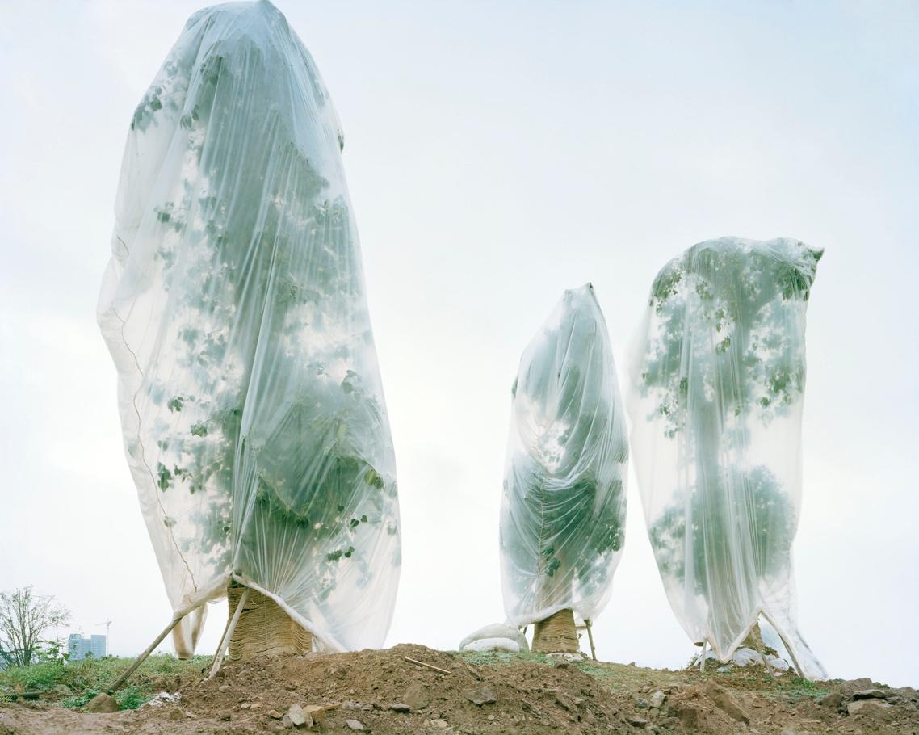
Figure 3: Central Park, University City, Chongqing, China, 2011. From Forest series (2010-2017). ©Yan Wang Preston
The latest work Autumn, Winter, Spring and Summer highlights intervention in Wang Preston’s working process. Yet the commitment to the body, time and materials are consistent to her earlier work. From the autumn of 2020, Wang Preston selected one tiny

rhododendron shrub in the same area and systematically worked through the following four seasons with its shedding materials including: all of the falling red leaves in the autumn, all of its seed capsules and aborted buds in the winter, and all of its fallen flowers in the spring and summer. From collecting, to burning and dissecting, Wang Preston responded to each material differently. With the consideration of her own multicultural history, Wang Preston made a 6-metre Chinese scroll with the autumn leaves, serial prints with the seed capsules, an artist book with the aborted buds, before completing the series with a 5-foot lightbox of sculpted fallen flowers.

Through the making of With Love. From an Invader. and Autumn, Winter, Spring and Summer, Wang Preston firmly embeds the body in the landscape and in turn, the politics of gender, race and migration come to the forefront of her artistic investigation. As with her earlier work, such issues are explored in the setting of the physical landscape and its pictorial representation.

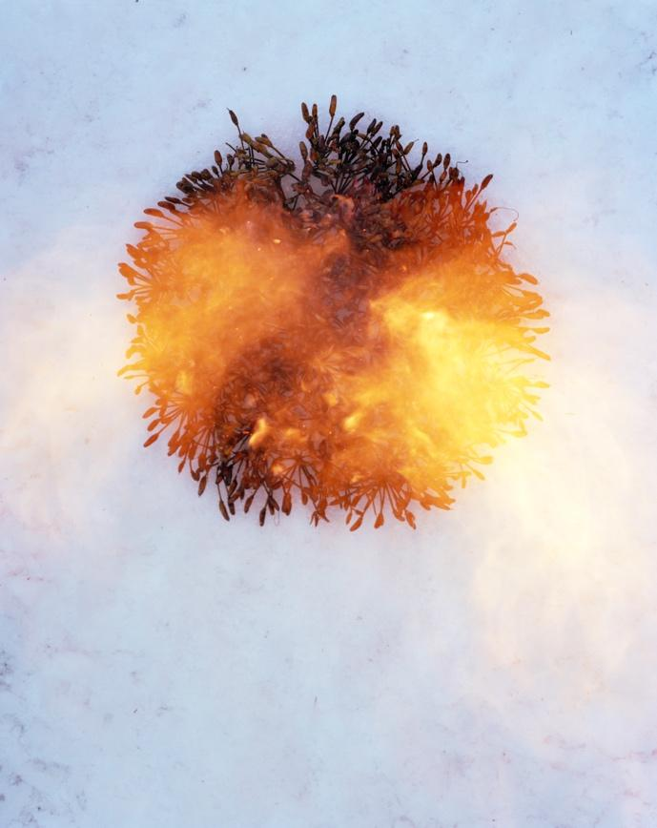
Figure 4: Winter-Seed Capsules. From Autumn, Winter, Spring and Summer series (2020--2022). © Yan Wang Preston
With Love brings together the genesis of a photographic journey that has been steeped in landscapes of origin, found and made. The exhibition also poignantly presents a new direction for the artist, one that involves a committed engagement with the landscape through the artists’ body, driven by a predetermined rhythm and a compulsive routine that become studies of acts and presence. To perform is to be present. And with that, Wang Preston firmly places herself in a new dialogue of discovery.

BIOGRAPHY

Dr Yan Wang Preston is a British-Chinese artist interested in the intercultural connections between landscape, identity and migration. Her work has won many international awards such as the 1st Prize, Syngenta Photography Award 2017 and the 1st Prize, Professional Landscape, Sony World Photography Awards 2019. She has exhibited widely and internationally at venues including Jeddah Photo 2022, Fotofest Biennial 2020, Houston USA, Gallery of Photography Ireland, the 56th Venice Biennale and Three Gorges Museum, Chongqing, China.

Current and Upcoming exhibitions include: Forest, in Biennale für aktuelle Fotografie, Mannheim, Germany, Mar-May 2022; Autumn-Leaves, in Rhododendrons: Riddle Obsession Threat, Inverleith House, Royal Botanic Garden Edinburgh, Apr-Jun 2022; and With Love. From an Invader. (solo exhibition), John Hope Gateway, also at RBGE, UK, May-Aug 2022.

Preston’s monographs are Forest and Mother River (Berlin: Hatje Cantz, 2018). She received a PhD in Photography at the University of Plymouth in 2018 and currently lectures at the University of Huddersfield, UK. She was originally trained in Clinical Medicine in Fudan University, China.

ONLINE TALK: Body, Land and Photography

Charlotte Jansen and Yan Wang Preston in Conversation.
Introduced By Zelda Cheatle. Wednesday 1 June, 2 pm Register here

A discussion with artist Yan Wang Preston in relation to the four major bodies of work in her solo exhibition With Love at Messums London, completed in the UK and China over the last decade. Wang Preston discusses finding a feminist language within the male-dominated canon of landscape art, exploring postcolonial dialogues in relation to ecosystems, and the endurance-based process behind her photographic practice.
PRESS
For press images, please contact: press@messumswiltshire.com
For further information about Yan Wang Preston’s photographs, please contact Mary George at photography@messumswiltshire.com
Launched in May 2021 with a programme of talks and exhibitions featuring international, renowned and emerging artists and photographers working in various parts of the world, Messums Photography favours dialogue between contemporary imagery and archives, reflecting on the evolution of photography as a storytelling genre.
MESSUMS WILTSHIRE is a leading multi-purpose gallery and arts centre set inside a restored thirteenth-century tithe barn and surrounding buildings with exhibition space, sculpture garden and restaurant.
MESSUMS LONDON is a modernist gallery space on Cork Street where the family have had a presence since 1992.

